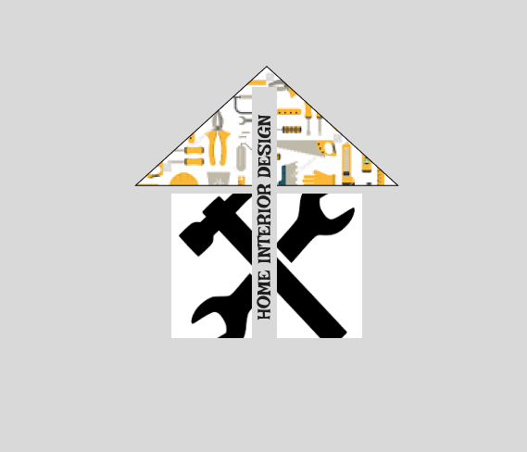

1. Law of common region: The Triangle is composed of similar tools and that makes a complete picture that resembles a roof
2. Law of Proximity: The triangle has different items grouped together and is perceived as one object. The hammer and spanner is grouped together to form the walls of the house.
3. Law of Similarity: The rectangle contains tools of the same colour as well as the triangle